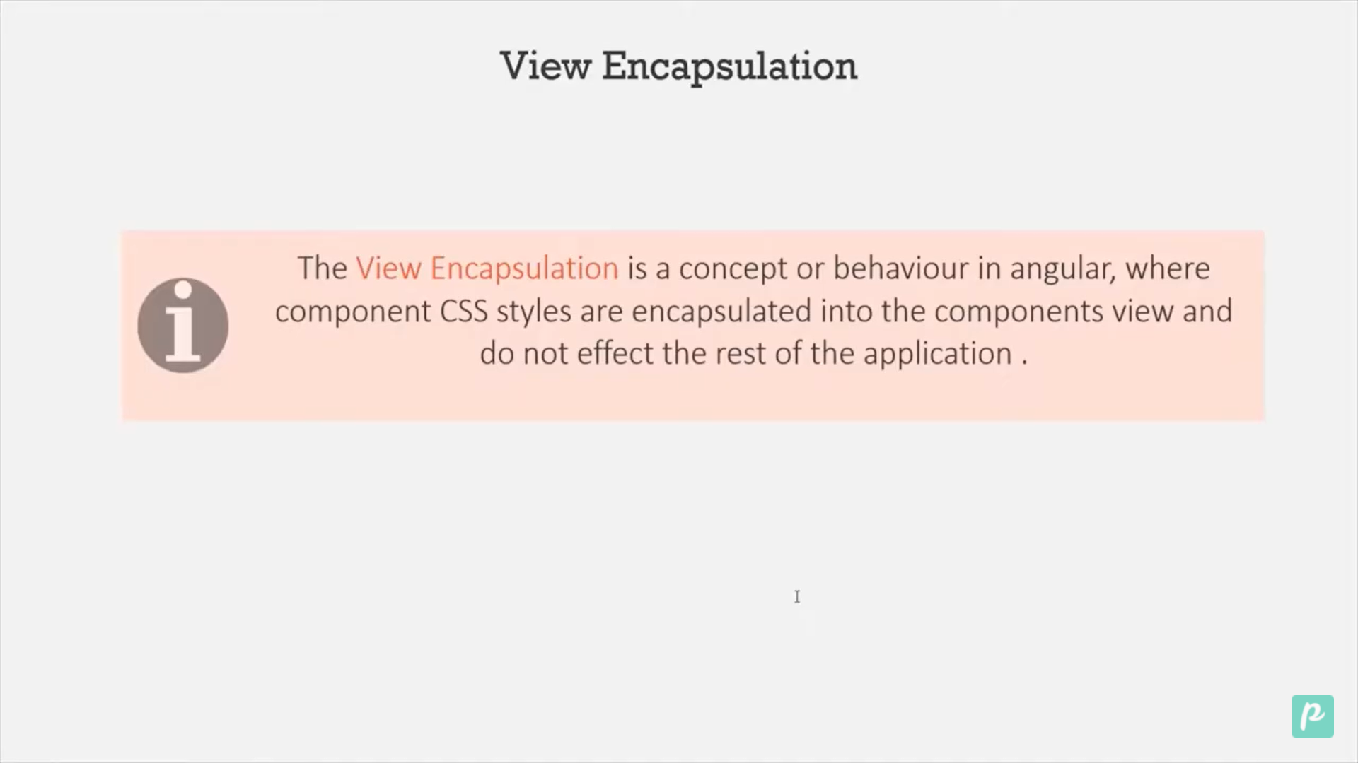

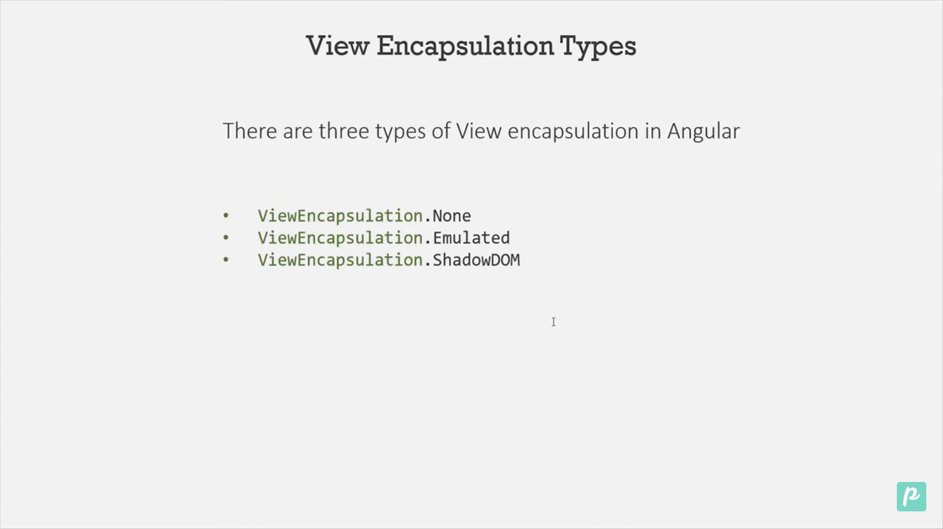

On emulated an attribute is assign to each component and stylesheet is applied that only.

For none

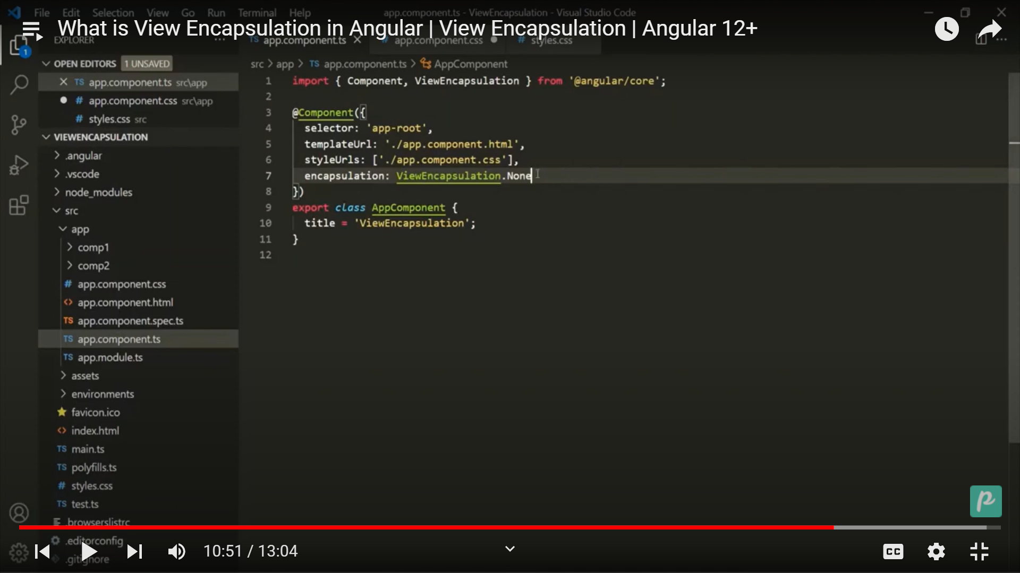

The button css will be applicable to it’s child also

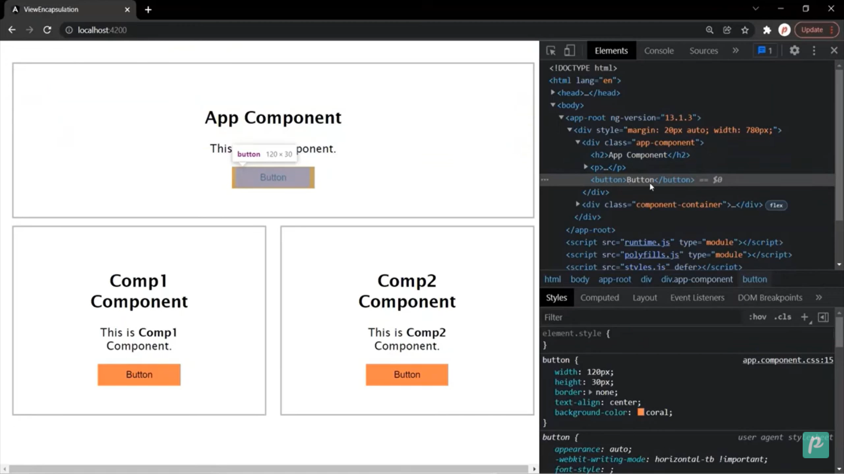

When we add a style on style.css file

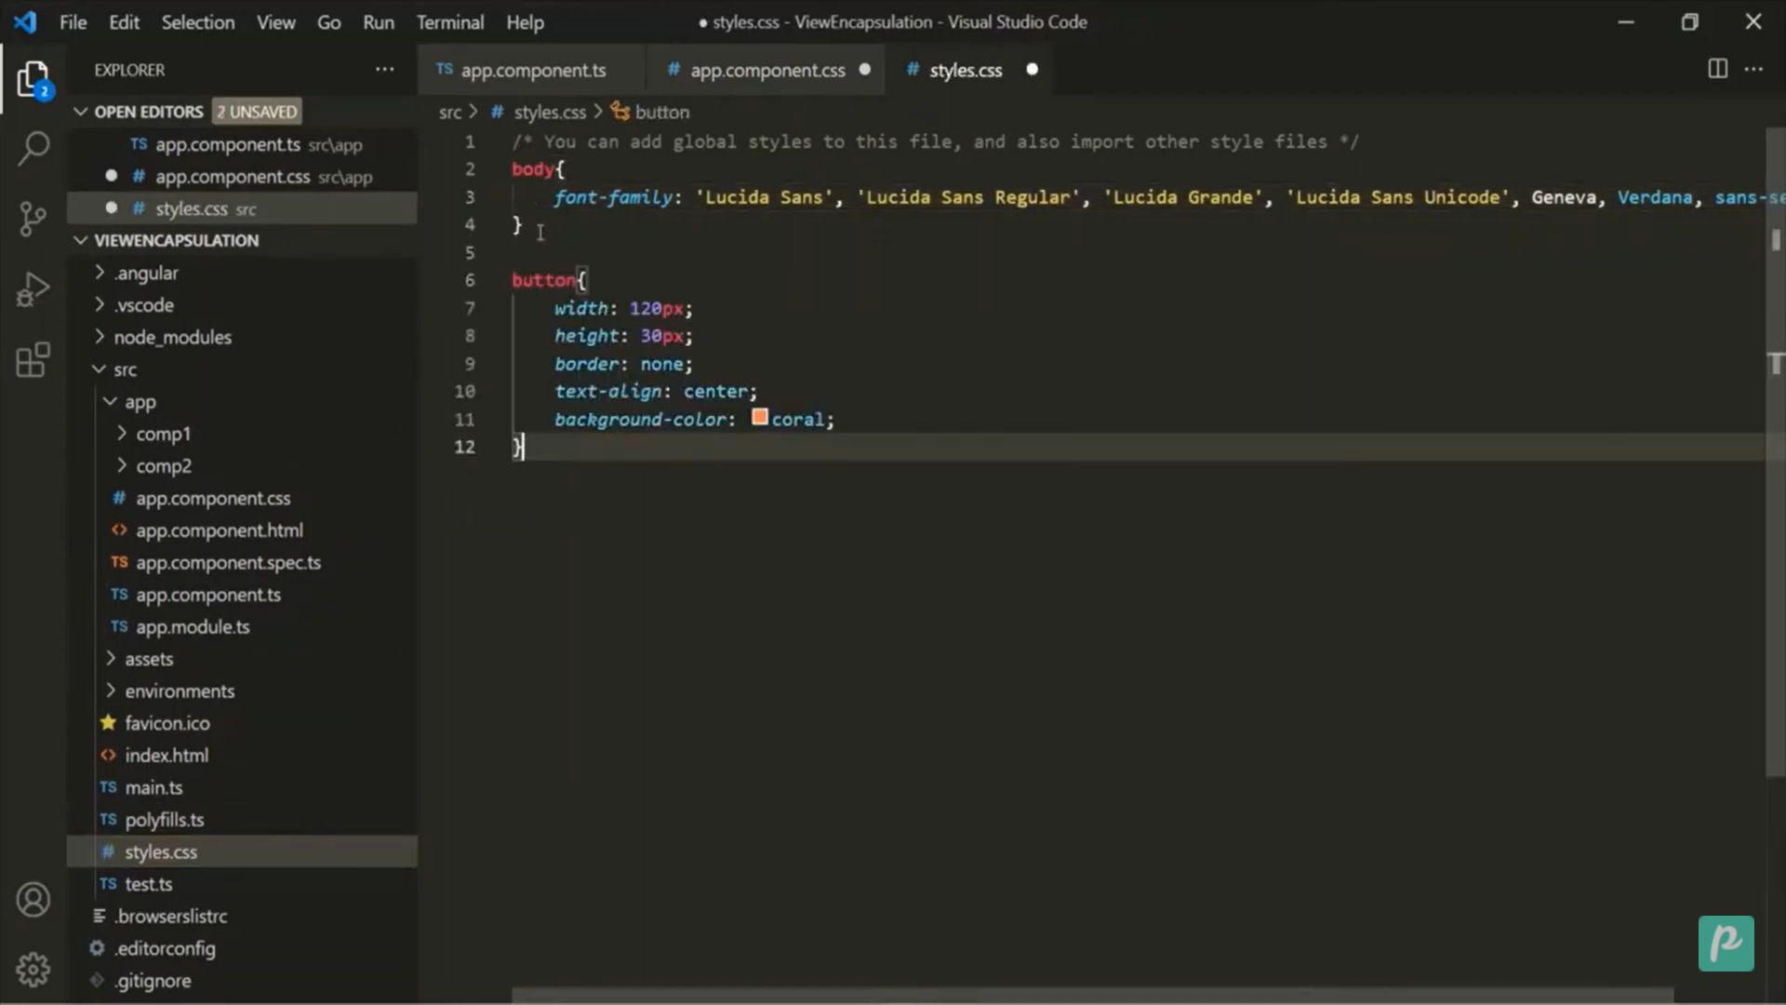

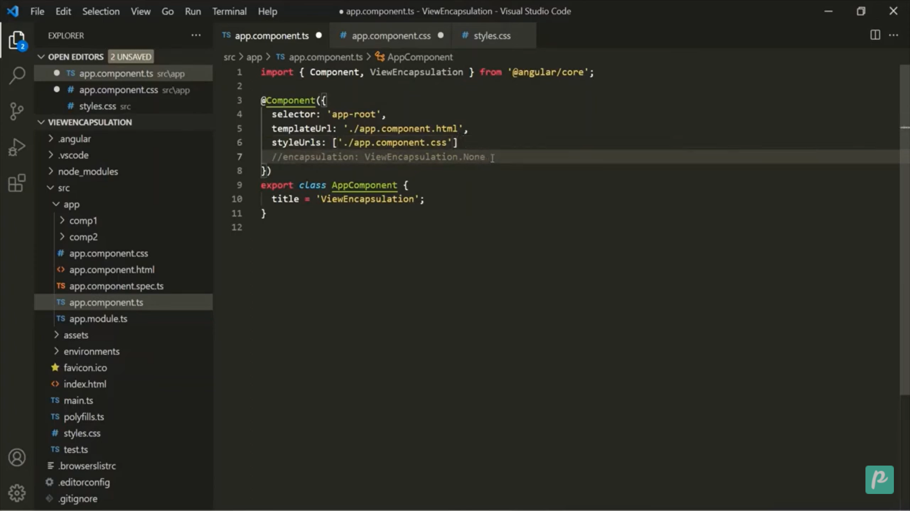by default emulate is used.

When we create a shadowDOm component it creates it’s own Dom and globally style sheet is not applicable

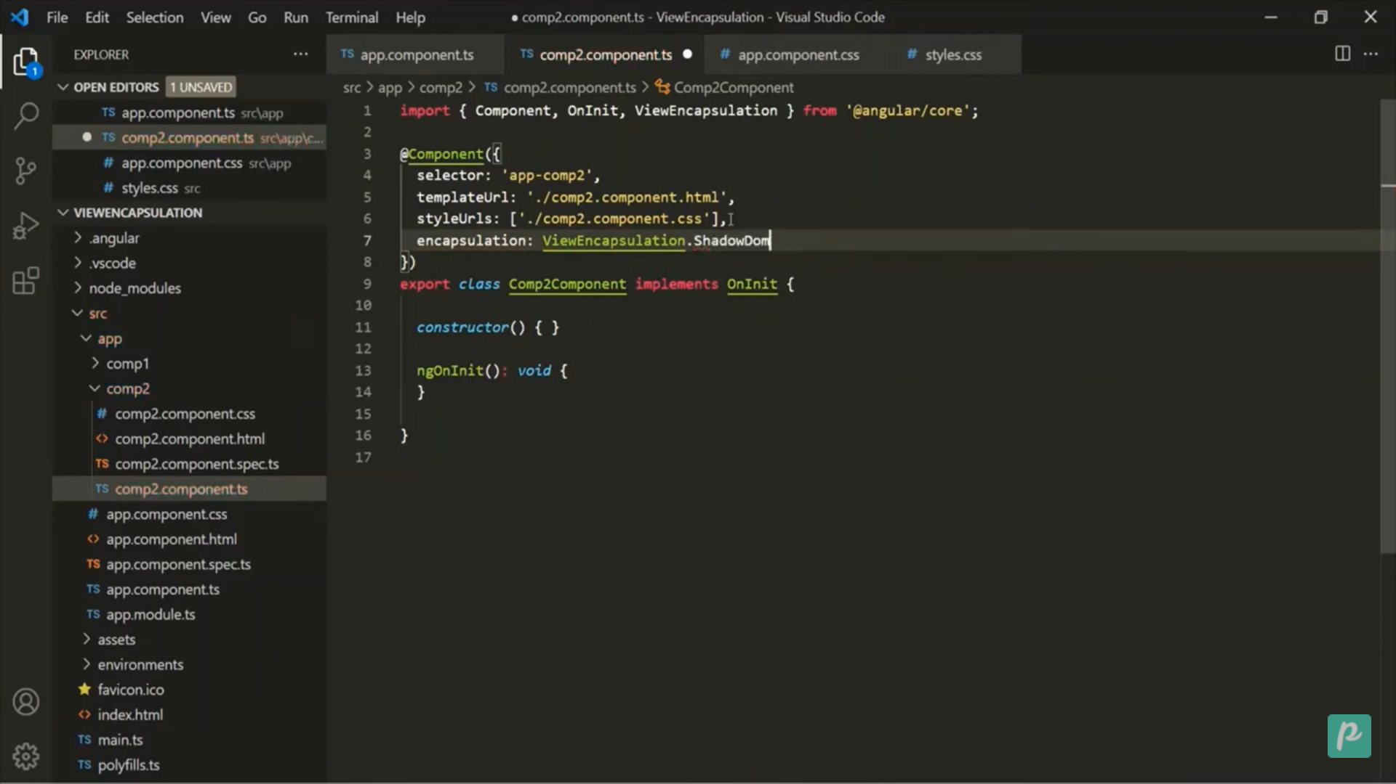

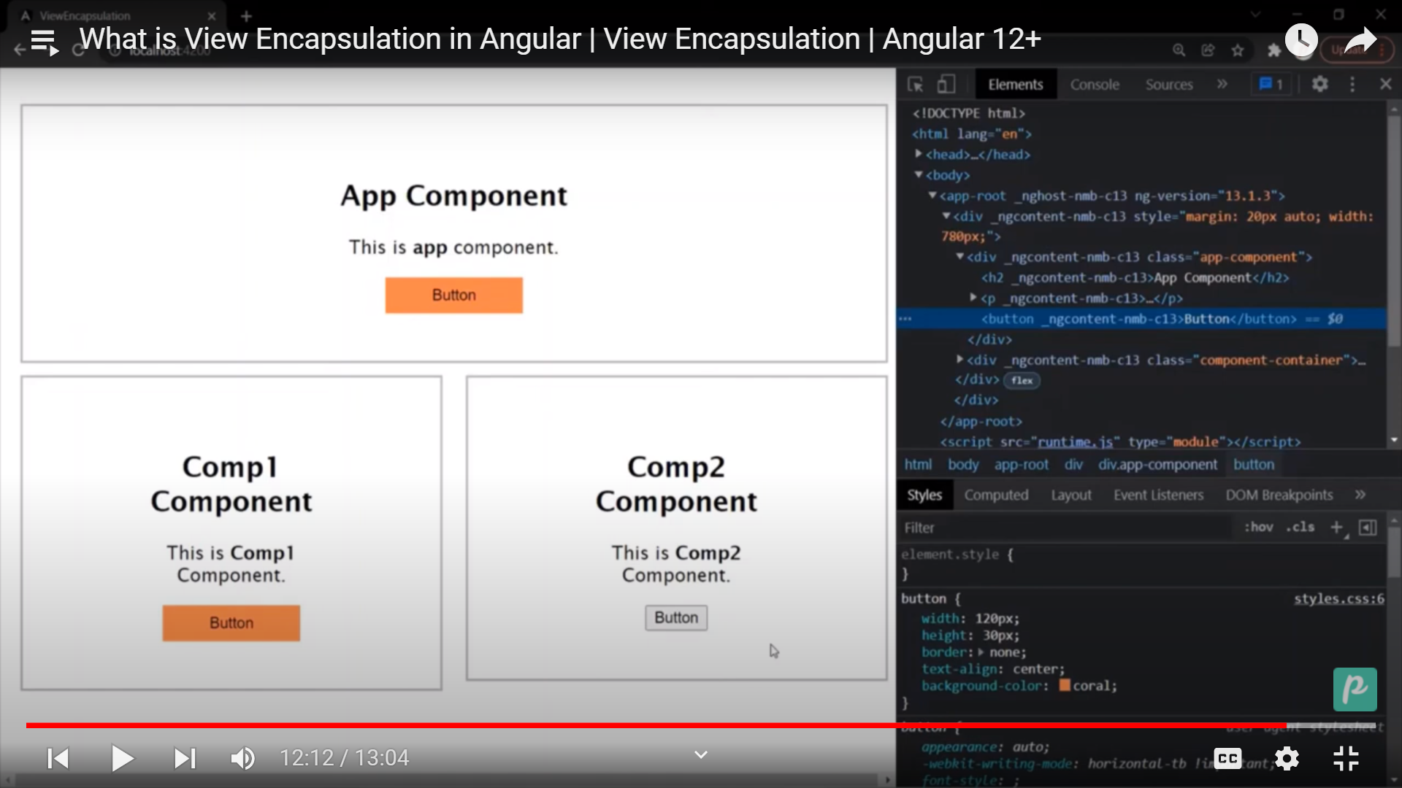

It will keep the shadowdom seprate from main dom.

@View Child

<label>D.O.B</label>&nbsp;&nbsp;&nbsp;&nbsp;&nbsp;&nbsp;

<input type="date" #inDob (input)="calculateAge()" />

<br />

<label>Your age is </label>

<input type="text" #inAge />

import { Component, ViewChild, ElementRef } from '@angular/core';

@Component({

  selector: 'app-viewchild',

  templateUrl: './viewchild.component.html',

  styleUrls: ['./viewchild.component.css'],

})

export class ViewchildComponent {

  @ViewChild('inDob') birth!: ElementRef;

  @ViewChild('inAge') age!: ElementRef;

  calculateAge() {

    let birthYear = new Date(this.birth.nativeElement.value).getFullYear();

    let currentYear = new Date().getFullYear();

    let valu = currentYear - birthYear;

    this.age.nativeElement.value = valu;

  }

}